December 16, 2022
CoC Business Meeting Minutes
9:00am-10:15am
Zoom

Recording: https://youtu.be/UPqvEkaAyTg
Attendees listed at end of document

- CoC Funding/Capacity Building/Planning
  - HUD has not yet made announcements about funding awards, but this is expected soon.
- Annual Review
  - Collaborative case conferencing (Jess)
    - Now case conferencing consists of two groups for Nassau and Suffolk which involve more stakeholders at the table including, shelter providers, rapid rehousing (RRH) providers, and DSS.
  - Property engagement cohort with Built for Zero (Mike)
    - The CoC has been partnered with Community Solutions (BFZ) for several years and worked on by-named lists to better identify and serve everyone experiencing homelessness, determine how to do outreach, connect to resources, and work on housing options. This model helped move case conferencing forward.
    - Recently LICH applied for capacity building funds to develop landlord engagement for people who have vouchers or rental assistance and need help leasing up. This is a highly requested service from people with lived experience and can help limit traumas people experience from doing their own housing search and experiencing housing discrimination. Capacity building might include additional staff, guidance, tools, working groups, and development of best practices.
  - Emergency Housing Voucher program (Rose)
    - The program moved 250 households into units in the past year from shelter and rapid rehousing programs. There are currently 70 households with active vouchers, and 105 households have had a briefing on the program. The CoC referred 200 vouchers this year, with 70 more referrals to come by the end of the year.
    - The EHV post-move case management program has 77 active participants in this voluntary services. Case managers assist with how to be a good tenant, budgeting, making sure the rent is paid and that households know what their rent amounts are. During the holiday season, case managers have been busy delivering donation baskets and gifts for household members. This program is hiring in order to assist more families.
  - New Coordinated Entry Assessment Tool (Al)
    - Over the course of about a year, the Coordinated Entry steering committee developed a new assessment tool that centers equity, is person-centered, and trauma-informed. The CoC Governance Board also approved a new prioritization policy whereby households will be prioritized for services by length of time homeless with the score on the CE assessment tool being used as a tie breaker. The goal of the tool is to prioritize households with highest barriers and greatest vulnerabilities. The tool was developed with several rounds of feedback from people with lived experience and will be continuously improved as more feedback is received.
  - Diversity, Equity & Inclusion training series (Mike)
    - The CoC hosted a DEI training series this summer with both in person and virtual sessions, hosted by the Technical Assistance Collaborative (TAC). Equity work carried forward from the training series includes discussions on power dynamics and how who is represented in decision-making situations differs from how I diverse and equitable group would look. Work to expand the influence of people with lived experience is underway within the CoC. The CoC will be contracting with TAC again next year and plans to make more DEI materials available.
  - Expansion of street outreach projects (Mike)
    - The need for street outreach has rapidly expanded in the past year. ESG funding has increased capacity. LICH, United Veterans Beacon House (UVBH), and Long Island Cares were funded for street outreach in Nassau, and LICH was also able to build capacity in the Town of Brookhaven through their ESG funds.
    - During the supplemental funding round to address unsheltered homelessness (SNOFO), four applicants applied to create or expand street outreach programs in both counties.
    - The Point in Time (PIT) count is coming up and should help engage the community in outreach and what is needed for people on the street.
  - ESG-funded low barrier shelter, The INN in Nassau (Al)
    - The INN’s low barrier program recently ended. The program was funded through ESG funds and did not need to follow DSS eligibility requirements, which allowed them to move over 30 undocumented households inside immediately and provide services at a centralized location. This was an important demonstration of how low barrier shelter can work in the region and provided important lessons on how to improve shelter access.
  - Supplemental NOFO (Greta & Al)
    - The CoC submitted applications for $12 million in funds for permanent supportive housing, transitional to rapid rehousing, and street outreach programs. Almost all applicants do not currently have CoC funding and some are new to the CoC. We are unsure how much of the funds we will be awarded, but that announcement should be coming soon.
  - Rental Supplement Program through DSS (Mike)
    - NYS launched a new initiative with an enhanced rental assistance rate to remove barriers for households working on exiting shelter. Eligibility requirements are more flexible and can be accessed by undocumented households. Applications are submitted on the county level, and both county programs are in the planning stages. The programs are looking to target populations that can best benefit and are not able to access other resources. Suffolk County is having conversations on addressing street homelessness and providing resources to large families and non-citizens. Nassau County is looking to do a local assessment of needs for families, single adults, and motel stayers. Nassau put out request for proposals for the program for an outside entity to administer it.
  - Empire State Supportive Housing Initiative (Jess)
    - Coordinated Entry (CE) has had great success placing single adults in Self Help’s ESSHI program in the Bergen apartment sin Freeport. Almost all (13 out of 14) households referrals were able to sign their leases yesterday, including some adults living on the street who were able to stay in their units last night. More CE referrals to ESSHI in 2023.
    - ESSHI grants are available to non-profit organizations doing capital projects or that already own housing to provide funds for support services and operations. The Local CoC must sign off on these projects, which must also commit to using HMIS.
    - In the last round, the CoC received 15 requests for support for over 250 units. It is unclear how many will be starting up and which timeline. The CoC will be meeting with the programs in January.
  - CoC programs starting
    - Al - ECLI/VIBS and Brighter Tomorrows have domestic violence RRH and TH-RRH programs that will be starting shortly.
    - Donna O’Hearon - Mercy Haven started working with DV Coordinated Entry for existing programs. Using ESSHI, four units are projected to open in February.
    - MaryEllen Adams, madams@hfyny.org - Hope for Youth is planning to open their TH-RRH program in January. In the past months, the program has had to get approval for changes and transition out residents for previous runaway youth shelter. The TH-RRH program will serve older participants, aged 18-24, and will have funding to allow participants to directly access RRH. There will be 24/7 staff, case management, and RRH supports. The program is looking into how other programs have successfully operated to develop their policies. The program is hiring staff currently.
  - Street Medicine (Mike)
    - Medical access is a significant service gap for people experiencing homelessness, especially those living on the street. Prompted by COVID-19, conversations are underway with partners interested in finding ways to have new street outreach medical initiatives. Multiple entities in both counties have been engaged, with some participating in initial shadowing outreach or collaborative outreach to pilot services. There has been some success some far in helping more people access psychiatric evaluations, which facilitate access to housing through the SPA application process.
  - Lived experience advisory group (Al)
    - The CoC is facilitating a lived experience advisory group to elevate the voices of people who have experience homelessness on Long Island. The group will be providing feedback on CoC programs and advocacy for issues that are important to group members. The group started in September of 2022 and is still actively recruiting. Please reach out to Al Licata (alicata@addressthehomeless) if you know anyone who is interested in joining. Compensation for time in meetings is provided.
  - Advocacy for shelter eligibility requirements (Mike)
    - OTDA is soliciting feedback on challenges accessing shelter. NYS has been getting CoCs together and will be working on ways to get feedback from the community and send that feedback to OTDA. Eligibility polices appear to be state level statutes, but there is an increased interested in in more streamlined feedback and how to look at shelter access differently. Thus far, some potential discussion points to raise with OTDA includes ideas on how to improve shelter access, advocacy for low barrier shelter options in communities, and further explorations of barriers people residing in shelter face, such as shelter payment standards. The NYS group of CoCs will be creating a survey to obtain feedback from shelter providers and people with lived experience.
- Coordinated Entry System Updates
  - Coordinated entry has referred 150 households for rapid rehousing and 40 households for permanent supportive housing in 2022. This does not include non-CoC SPA housing, which the CE team has been able to leverage for several households. In the past month, there were 12 referrals to RRH and there is an expectation that there will be 5 new PSH referrals by the end of the year. A referral is being made to the last Self Help ESSHI bed.
  - CE – 150 RRH, 40 PSH for 2022 (not including non-CoC SPA)
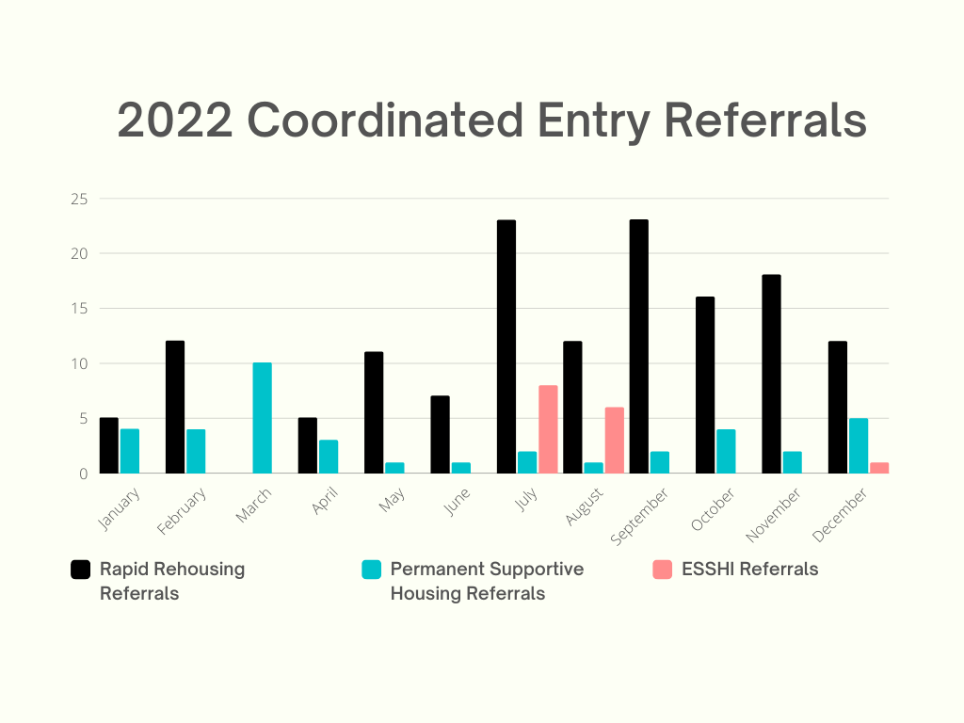
  - Domestic Violence Coordinated Entry will be moving in two clients with EHV in December and made 3 referrals to RRH this month. TSCLI able to divert 2 clients with flex funding by providing help with security deposits. The employment specialist was able to assist 15 clients secure full time and 9 secure part-time employment
- HMIS Updates
  - Jan 2023 HMIS trainings:
    - Jan 11, 2023 (New User) and Jan 18, 2023 (Intermediate Reports)
    - 2 trainings in February
      - In-person on 2/16, new user training
  - Annual agreement announcements will be sent out today (by agency), please return by or before the deadline in the email. The emails will include an active user list. Responses will be accepted via email to record date received, but will have to be sent in paper form as well. New users need to sign the agreement even if they signed an agreement at the end of 2022.
  - If a user is no longer using HMIS, let Roxzelle know immediately and she will remove them. The removal cannot be back dated for billing purposes. Every agency (except uploading agencies) is responsible for asking for user removal. CoC gets billed for every bundle of users per organizations and then bills organizations. All users must be removed right away for privacy considerations of people who’s data is in HMIS.

- Community Announcements
  - Greta’s 26th year anniversary at LICH and the CoC is today!

Attendees
George Stone, MHAW
Brian Inserro, FREE
Diane Krasnoff, Bethany House
Greta Guarton, LICH
Ariel Sotelo, LICH
Daniela Franco, Brighter Tomorrows
Jesse Delman, Bridges of NY
Ruth McDade, MHAW
Vicki McGinn, Suburban Housing
Terri Tupper, LICH & LI Connections
Donna O’Hearon, Mercy Haven
Lorraine Baum, CNG
Angel Macchia, NC Community Development
Erin Basham, Options for Community Living
Nicole Maggiotta, The Safe Center LI
Judelca Batista-Reyes, LICH
Rose Cicchetti, LICH
Petal-Bowen-Walcott, LICH
Jestine Jennings, FCA
Vicki Cooper, The Retreat
Ann D’Amico, MHANC
Chanee Hamonds, Wyandanch Homes & Property Development Corp.
Cara Cantor, Hope for Youth
Sam Polins, LICH
Sydney Dyer, ECLI-VIBES
Deirdre Trumpy, MOMMAS House
Kristin Ohrthman, HELP Suffolk
Shannon Boyle, New Ground
Kelly Gildea, Suburban Housing
Gabrielle Fasano, SUS
Stephen Brazeau, Hope House Ministries
Jessica Labia, LICH
Elizabeth Lunde, Concern
Kathy Henry, MHANC
--- after 9:20am ----
Karen Haber, Huntington Youth Bureau Sanctuary

