Narrative Instructions and Guidance

Local CoC Questions related to Diversity, Equity and Inclusion (DEI), Involving People with Lived Experience (PLE) and Advancing Racial Equity to be scored in Local Ranking/Review.

These questions are not in esnaps, therefore please complete these questions separately, using this external Word document (save a PDF once completed), to be emailed along with the completed esnaps application as a PDF). Please review the full checklist of documents that must be submitted as part of the application, outlined in the instruction manual.

These narrative questions represent a total of 10 out of 70 points on the CoC Renewal Scorecard, or 14.3% of total program performance. Please reference the scorecard and scoring rubric below for more details.

NOFO References to involving Persons with Lived Experience:

Involving Persons with Lived Experience. The people who know best what solutions will effectively end homelessness are those who are experiencing homelessness. HUD expects CoCs to include people with lived homeless expertise and experience in their local planning and decision-making process. People with lived experience should determine how local policies may need to be revised and updated to improve the effectiveness of homelessness assistance programs, including participating in planning and oversight activities, and developing local competition processes. CoC leaders and stakeholders should prioritize hiring people who have experienced homelessness in areas where their expertise is needed.

Addressing the Needs of Victims of Domestic Violence, Dating Violence, Sexual Assault, and Stalking. Addressing the Needs of Survivors of Domestic Violence, Dating Violence, Sexual Assault, and Stalking. Coordinate with survivors and people with lived experience, victim service providers, and operators of coordinated entry to address the unique needs for housing and safety that prioritize housing defined as safe by survivors. The CoC must identify the current efforts to increase access to housing and services defined as safe by survivors of domestic violence, dating violence, sexual assault, and stalking, adopting survivor-centered practices that maximum client choice while maintaining safety and confidentiality.

Advance Racial Equity in the Local CoC Process: projects are rated and ranked based on the degree to which their project has identified any barriers to participation (e.g., lack of outreach) faced by persons of different races and ethnicities, particularly those over-represented in the local homelessness population, and has taken or will take steps to eliminate the identified barriers.

Involving Individuals with Lived Experience of Homelessness in Service Delivery and Decision-Making and Provide Professional Development and Employment Opportunities. The CoC has included persons with lived experience of homelessness in the CoC’s decision-making process, and the CoC encourages CoC members to provide professional development and employment opportunities to people experiencing homelessness.

• outreach efforts (e.g., social media announcements, targeted outreach) to engage those with lived experience of homelessness in leadership roles and decision-making processes;
• individuals with lived experience of homelessness participate in CoC committees, subcommittees, or workgroups;
• individuals with lived experience of homelessness are routinely included in decision-making processes of the CoC related to addressing homelessness (e.g. minutes from CoC or CoC Subcommittee meetings show people with lived experience are involved in decision-making);
• individuals with lived experience of homelessness are included in the development, or revision, of the local competition rating factors;
• individuals with lived experience of homelessness are included in the development of the CoC’s coordinated entry process;
• professional development (e.g. internships, continuing education, skill-based training) and employment opportunities are provided to individuals with lived experience of homelessness either within the CoC or by CoC membership organizations; and • feedback is routinely gathered from people experiencing homelessness and people who have received assistance through the CoC or ESG program on their experience receiving assistance and the steps the CoC takes to address challenges raised by people with lived experience of homelessness.

Effectively Count Youth. Implement specific measures to identify youth in the CoC's PIT count. Demonstrate that for the 2023 PIT count, the CoC:
• engaged youth serving organizations and youth experiencing homelessness (including unaccompanied youth) in your most recent PIT count planning process;
• worked with youth serving organizations and youth with lived experience of homelessness to select locations where youth experiencing homelessness are most likely to be identified; and
• involved youth experiencing homelessness in the actual count.

Local Focus considered in ranking:

- Diversity, Equity, and Inclusion / Involving Persons with Lived Experience (PLE)
- Involving PLEs in program design
- Involving PLEs in program implementation
- Involving PLEs in program improvement
- Professional development and employment opportunities or PLEs
- PLE feedback compensation
- Certified Peer Specialist staff
- Identifying and planning around barriers for greater PLE involvement and program access

Narrative Scoring Rubric for Completeness:

Total Score- Point Ranges | Incomplete | Elementary | Satisfactory | Thoughtful and Complete
3 points | 0% = 0 points | 50 = 1.5 points | 75 = 2.25 points | 100 = 3 points
2 points | 0% = 0 points | 50 = 1 points | 75 = 1.5 points | 100 = 2 points
1 point | 0% = 0 points | 50 = .5 points | 75 = .75 points | 100 = 1 point
Evaluation  Criteria | Applicant provides an incomplete response to the question. The submitted answer is incomplete, and does not incorporate HUD/CoC training, practice standards or specific examples. Applicant does not demonstrate ability to identify areas of DEI work and/or an emphasis on including people living experience and those marginalized. | Applicant provides an elementary response to the question. The answer is incomplete but shows a basic ability to integrate HUD/CoC training, practice standards or specific examples. Applicant demonstrates basic ability to identify areas of DEI work and/or an emphasis on including people living experience and those marginalized. | Applicant provides a satisfactory response to the question. The answer fulfills the requirements of the question and shows an ability to integrate HUD/CoC training, practice standards or specific examples. Applicant demonstrates ability to identify areas of DEI work and/or an emphasis on including people living experience and those marginalized. Applicant is developing the ability to integrate DEI knowledge into practice. | Applicant provides a thoughtful and complete response to the question. Applicant can clearly integrate Student can integrate HUD/CoC training, practice standards or specific examples. Applicant demonstrates strong ability identify areas of DEI work and/or an emphasis on including people living experience and those marginalized. Applicant successfully able to integrate DEI knowledge into practice.

Local CoC Narrative Questions to be Completed by ALL Renewal Applicants:

- [3 points total] Please describe at least one specific way that your program involves people with lived experience in A) program design [1 point], B) implementation [1 point], and C) improvement [1 point].

A)

B)

C)

- [2 points] Please describe whether and how PLEs are compensated for their time and feedback, such as through participation in focus groups or advisory boards, including if they are paid staff.

Response:

- [2 points] Please identify at least one specific barrier [1 point] and at least one specific attempt [1 point] to increase participation of PLEs in program design, implementation, and improvement.

Identified Barrier:

Attempt to Remove Barrier:

- [1 point] Please describe PLEs specific opportunities for professional development/employment and/or PLE certifications offered by the program.

Response:

- [2 points- all or nothing, documentation required] Is a current staff member(s) associated with this specific CoC-funded project peer certified?

- Yes/No

- Role/Position within CoC-funded project

- If yes, documentation is required for confirmation.

- [Exploratory Question to enhance CoC Best Practices re: advancing racial equity]

Please identify specific barriers to participation (example- lack of outreach) faced by persons of different races and ethnicities, particularly those that are over-represented within the homeless system*, and steps towards eliminating those specific barriers.

Identified Barrier:

Steps to Remove Barrier:

Reference Information

HUD NOFO: Advance Racial Equity in the Local CoC Process: projects are rated and ranked based on the degree to which their project has identified any barriers to participation (e.g., lack of outreach) faced by persons of different races and ethnicities, particularly those over-represented in the local homelessness population, and has taken or will take steps to eliminate the identified barriers.

*Per the 2023 HUD Annual Homelessness Assessment Report (AHAR) report to Congress, people who identify as Black, Latino, American Indian, Alaska Native, Pacific Islander, or Native Hawaiian continue to be overrepresented among the homeless population compared to the U.S. population.

Local HUD Race Equity Analysis Tool Findings:

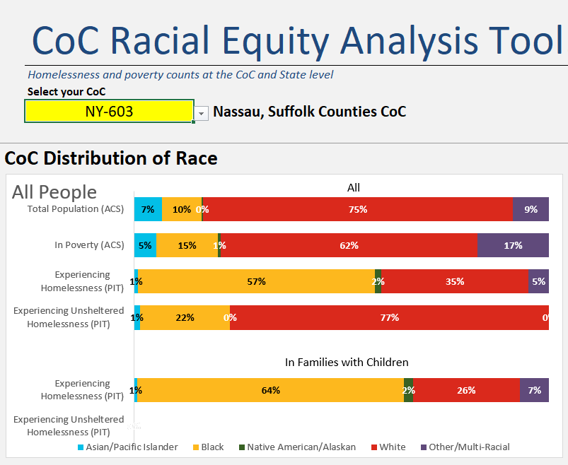

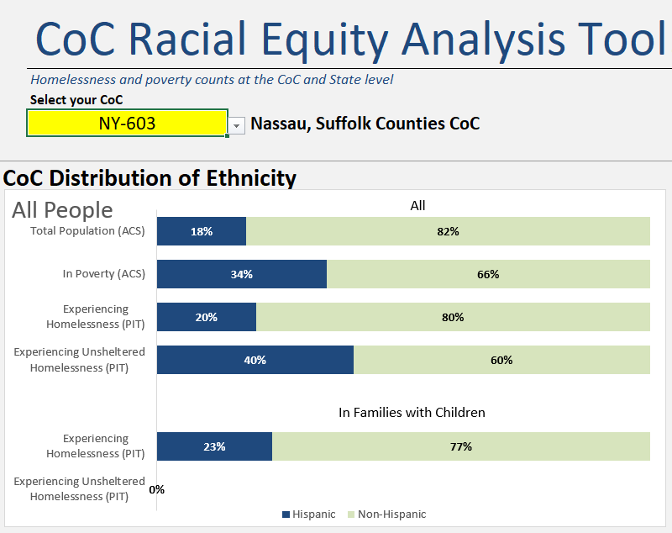

Run complete CoC Race Equity Analysis here: (NY-603) https://www.hudexchange.info/resource/5787/coc-analysis-tool-race-and-ethnicity/

*We acknowledge that this may not identify all groups that are marginalized/over-represented within the homeless system and that there may be intersectionality between different groups.

Intersectionality- “the complex, cumulative way in which the effects of multiple forms of discrimination [such as racism, sexism, and ableism] combine, overlap, or intersect especially in the experiences of marginalized individuals or groups.”
-HUD LGBTQIA+ Fair Housing Toolkit

https://www.huduser.gov/portal/sites/default/files/pdf/2023-ahar-part-1.Pdf

https://endhomelessness.org/homelessness-in-america/what-causes-homelessness/inequality/#:~:text=Most%20minority%20groups%2C%20especially%20African,standing%20historical%20and%20structural%20racism.

