**LI CONTINUUM OF CARE MONTHLY NEWSLETTER**

**ISSUE**

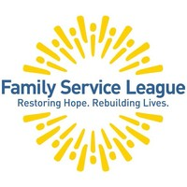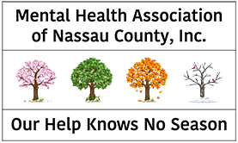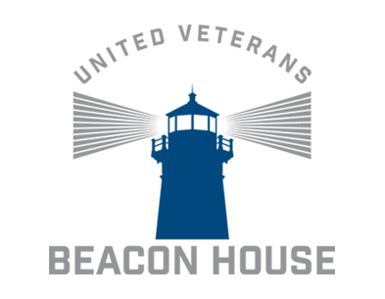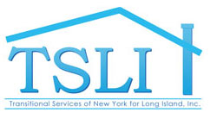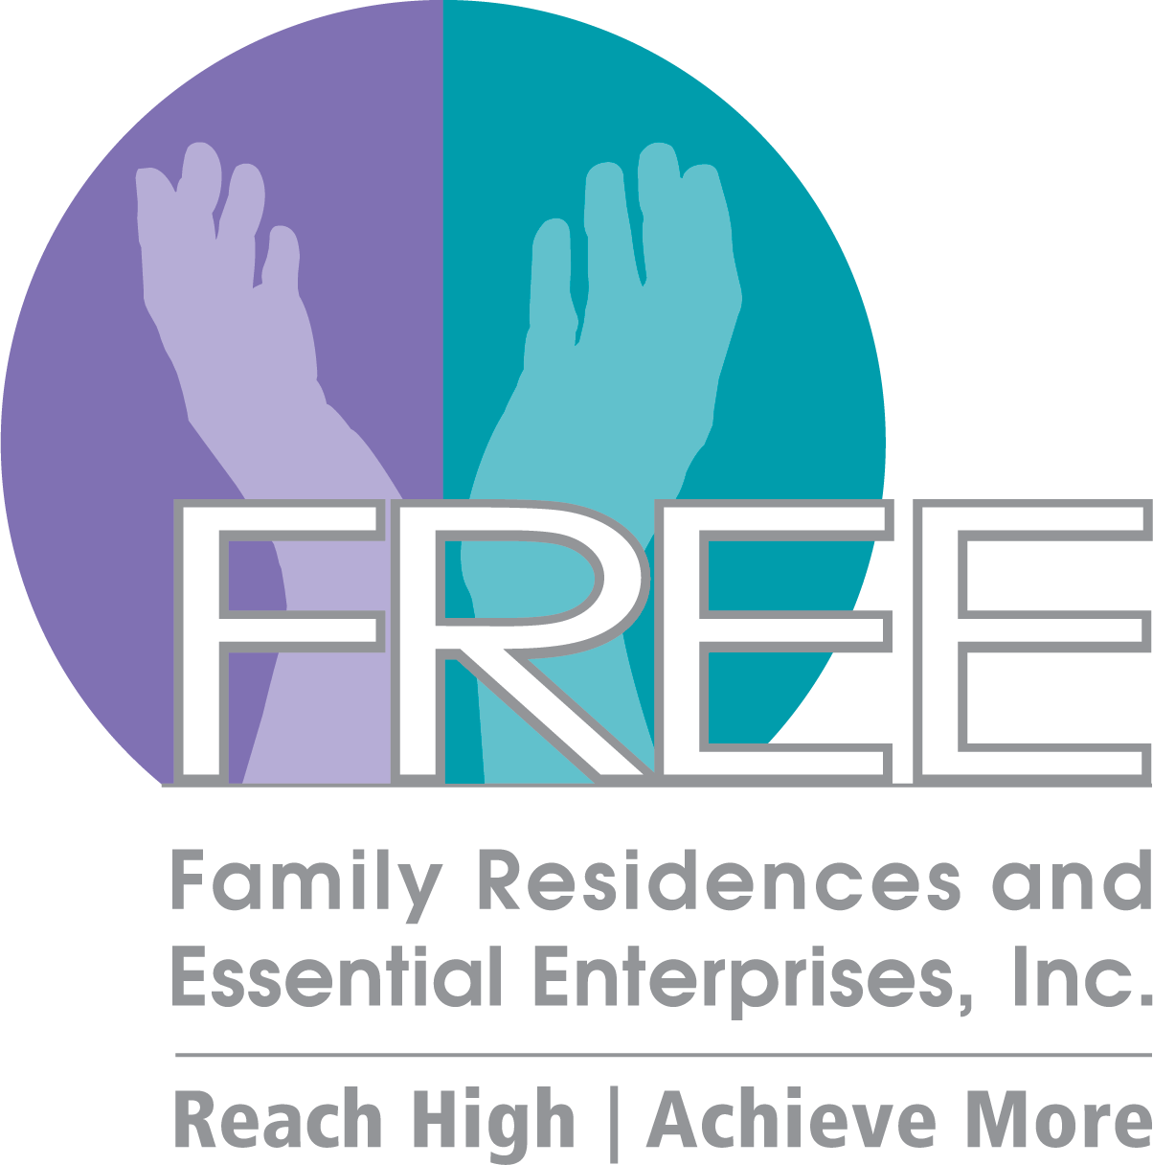

**2020 CoC Schedule**

**Announcements**

* The **CoC Business Meeting will resume virtually after this month.** Please refer to the CoC Newsletter for monthly updates
* The **CoC website** - **lihomeless.org** has a comprehensive list of resources pertaining to COVID-19 for people experiencing homelessness and their homeless service providers. There is also a list of food pantries which is updated regularly.
* All meetings will be online through WebEx or conference call line
* **The 2020 Census is NOW OPEN** - The results of the 2020 Census will help determine how hundreds of billions of dollars in federal funding flow into
* communities every year for the next decade. That funding shapes many different aspects of every community, no matter the size, no matter the location.
  + <https://2020census.gov/en.html>

**\*\*\*Please visit lihomeless.org for additional updates**

* <https://www.lihomeless.org/>
* <https://www.lihomeless.org/covid-19>

**\*DISCLAIMER: Undisplayed organizational logos could not be found online**



**CARES ACT**

* As part of the CARES Act (stimulus bill), there was an allocation of ESG and CDBG funds that will be awarded to all ESG jurisdictions based on local needs related to COVID-19
* Each jurisdiction is awaiting further information from HUD before issuing RFPs for grants to address local needs related to COVID-19
* <https://www.congress.gov/bill/116th-congress/senate-bill/3548/text>

**\*March 20th, April 17th, August 14 – Governance Board Meeting Only\***

JUL17

*AUG 14

SEP 25

OCT 16

NOV 20

DEC 18

JAN 17

FEB 21

*MAR 20

**\*APR 17**

**MAY 15**

JUN 19

**APR 2020**

*insert text*

**03ioo**

**Upcoming Webinars/Trainings**

1. **COVID-19 Planning & Response Office Hours: Mega Waiver and Cares Act** 
   1. Date: April 14, 2020 1:30 PM – 3:00 PM
   2. LINK: <https://www.hudexchange.info/trainings/courses/covid-19-planning-response-office-hours-mega-waiver-and-cares-act/>
2. **COVID-19 Office Hours Every Friday** 
   1. Next HUD Office Hours: April 17th 2:30 PM
   2. <https://abtassociates.webex.com/mw3300/mywebex/default.do?nomenu=true&siteurl=abtassociates&service=6&rnd=0.9106302223205388&main_url=https%3A%2F%2Fabtassociates.webex.com%2Fec3300%2Feventcenter%2Fevent%2FeventAction.do%3FtheAction%3Ddetail%26%26%26EMK%3D4832534b00000004395c90f0999f7e2776b4e51f17d239078ae219975fe23a573ad500f0a0fd81ef%26siteurl%3Dabtassociates%26confViewID%3D158167357693374093%26encryptTicket%3DSDJTSwAAAAToVXb3YKyvireuS5RQtavgA6nVA7hNmU_ArvtU2f6MYg2%26>

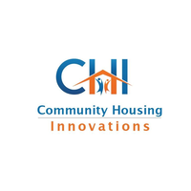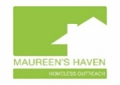

**HUD MEGA Waiver**

* Grantees must mail or email notification to the Community Planning and Development Director of the HUD Field Office serving the grantee.
* The mail or email notification must be sent two days before the grantee anticipates using waiver flexibility, and include the following details
  + Requestor’s name, title, and contact information;
  + Declared-disaster area(s) where the waivers will be used;
  + Date on which the grantee anticipates first use of the waiver flexibility; and
  + A list of the waiver flexibilities the grantee will use:
* 1. CoC Program - Fair Market Rent for Individual Units and Leasing Costs
* 2. CoC Program - Disability Documentation for Permanent Supportive
* Housing (PSH)
* 3. CoC Program – Limit on Eligible Housing Search and Counseling
* Services
* 4. CoC Program - Permanent Housing-Rapid Re-housing Monthly Case
* Management
* 5. CoC Program - Housing Quality Standards (HQS) – Initial Physical
* Inspection of Unit
* 6. CoC Program - HQS – Re-Inspection of Units
* 7. CoC Program – One-Year Lease Requirement
* 8. Consolidated Planning Requirements – HOME, CDBG, HTF, ESG, and
* HOPWA Programs – Citizen Participation Public Comment Period for
* Consolidated Plan Amendment
* 9. Consolidated Planning Requirements – HOME, CDBG, HTF, ESG, and
* HOPWA Programs – Citizen Participation Reasonable Notice and
* Opportunity to Comment
* 10. ESG Program - HMIS Lead Activities
* 11. ESG Program - Re-evaluations for Homelessness Prevention Assistance
* 12. ESG Program - Housing Stability Case Management
* 13. ESG Program - Restriction of Rental Assistance to Units with Rent at or
* Below FMR
* 14. HOPWA Program – Self-Certification of Income and Credible Information
* on HIV Status
* 15. HOPWA Program – FMR Rent Standard
* 16. HOPWA Program – Property Standards for TBRA
* 17. HOPWA Program - Space and Security

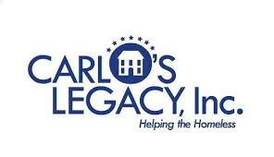











Suburban Housing



ADD/ADHD Housing Group INC.

**CoC Updates (Business Meeting)**

* **2020 Funding Round**
  + No updates or changes at this time
  + HUD is focused on guiding CoC’s through the current public health crisis
  + HUD Office Hours every Friday
    - <https://www.hudexchange.info/homelessness-assistance/diseases/#covid-19-webinars-and-office-hours>
* **CES Updates**
  + Community Solutions Built For Zero Learning Sessions for April 14-16 will still occur as remote online presentations. BFZ members will present on updates and best practices from around the country
  + The CES Team will be reaching out to all CoC-funded permanent housing programs to see if there were any CoC program changes related to program admissions that the CES team will need to adapt to during COVID-19
  + Some programs are still continuing to accept new referrals and completing intakes over the phone. If other programs are putting referrals on hold, please inform the CES team as we project client wait times (PSH and RRH) based on typical turnover and new client enrollments.
  + Our team has made 2 referrals to Concern OPP CoC Spa program and 3 referrals to Options Rapid Rehousing Program
* **HMIS Updates**
  + **COVID-19 Awareness Screening Tool Available in HMIS**
    - The screening tool (titled: COVID-19 Awareness Screening) is intended to help programs manage activities related to client awareness, potential personal contact, and general symptom monitoring. \***Please note: This is not intended to be a medical screening or diagnostic tool.** This tool is intended to assist programs manage activities related to your clients and the COVID-19 virus, it does not take the place of an actual medical diagnosis. \***You are not required by funding entity to use this screening tool**
    - **To access the screening tool in AWARDS/HMIS:**
      * Home>Charts>Medical>Forms:COVID-19 Awareness Screening
  + **HMIS Trainings** 
    - Ths HMIS team is working on remote, online training for HMIS new users (TBA)
    - The trainings will be conducted one-on-one (likely using WebEx)
    - The trainee will need to have a laptop to access the training program in the HMIS website and will need a second device (cell phone is fine) to follow along on WebEx
    - The training will cover all the important HMIS fundamentals but would be significantly shorter than the current full-day duration
    - A package of “how to” documents would supplement the online training
  + **A Note About HMIS Data Quality During the Coronavirus Outbreak**
    - As we move forward, we ask that if you are having difficulty or are unable to keep up with your program’s new HMIS intakes and discharges, to please send us a note indicating that.  It’s important that we at the Long Island Coalition for the Homeless, as the HMIS Lead and CoC Lead for Nassau and Suffolk counties, understand the state of our HMIS data quality so we can continue to use the data to make housing and intervention decisions with our clients.
* **Committee Updates**
  + Racial Equity Committee
    - What the COVID-19 Pandemic Means for Black Americans
      * <https://blogs.scientificamerican.com/voices/what-the-covid-19-pandemic-means-for-black-americans/>
    - Why people are being released from jails and prisons during the pandemic
      * <https://www.vox.com/2020/4/3/21200832/jail-prison-early-release-coronavirus-covid-19-incarcerated>
    - Tenants’ Rights for Tenants with COVID-19 or Under Home-Quarantine
      * <https://www1.nyc.gov/content/tenantprotection/pages/covid19-home-quarantine>
  + Youth and Young Adult Services Committee
    - The Impact of COVID-19 on the Youth Homelessness Crisis: What Providers Need to Know **(lihomeless.org > About > Youth/Young Adult Services Committee)**
    - The Renewed Importance of Direct Cash Transfers in Ending Youth Homelessness During the COVID-19 Pandemic **(lihomeless.org > About > Youth/Young Adult Services Committee)**

**\*\*\*Visit lihomeless.org for additional updates and COVID-19 resources**

**Peace Valley Haven**