January 19, 2024
CoC Business Meeting Minutes
9:00am-10:15am, Zoom

Recording: https://youtu.be/dzT_vtcChwk
Attendees listed at end of document

- CoC Funding Round
  - HUD has been reaching out to organizations starting 11/2023 for information on curable deficiencies. We have not heard of any awards being made at this time. Usually, awards are announced early in the year. The Collaborative Applicant (LICH) will notify others with any updates. The CoC Received notice to register for 2024 funding round already.
- Resource Presentation: Employment Training / PLE Considerations (Samantha Grimaldi, LICH)
  - Benefits cliff: increase of income from employment can be disproportionately impacted by lost of benefits, leaving recipients in a more precarious financial situation
  - Impacts self-sufficiency – people might avoid taking steps for better employment options because of the immediate negative impact
  - Open and conversation with the person can help determine where they are at and tailor a specific plan to their situation
  - Creative options: deferring a portion of increased earning, employer-sponsored benefits, creative bonusing and transitional assistance
  - Develop strategic plans with employers to plan raises and income ensuring benefits maintenance. Be creative, think outside the box
  - Benefits all have different formula for eligibility – can be gross income compared to poverty level (FPL) or area median income (AMI). Refer to slides for more detail.
  - Temporary increased income disregard for benefit adjustment – a new policy that allows for total 6 months over lifetime to not have income counted for benefit adjustment, as long income does not exceed 200% FPL
  - The average poor family with children receives $65,200 in cash, food, housing, medical care, and educational support from the taxpayer each year
    - 2021 - The Government Welfare Increase Report by "Heritage.org"
  - 80% AMI for our region is Appx $85,000 for a Low Income Family of 3
    - Emergency Rental Assistance Program 80% Area Median Income (ny.gov)
  - SSI amounts for 2024 The monthly maximum Federal amounts for 2024 are $943 for an eligible individual per month, $1,415 for an eligible individual with an eligible spouse per month.
  - SSDI SGA Limit: Starting in 2024, SSDI recipients will be allowed to earn up to $1,550 monthly from a job without putting their benefits at risk (up from $1,470 in 2023).
    - SSDI and SSI Are Changing in 2024 - A Breakdown Of New Benefit Amounts (oasinc.org)
    - Workers have to be careful, because some weeks have 5 months and you can easily go over
    - Ticket to work – gives you 9 rolling months of receiving SSDI while you are making a regular salary within a 5 year period
    - How to Get On – guide for people with disabilities,
    - Path program for self-sufficiency
  - Loss of benefits (including Medicaid) can have negative cascade effect, people can lapse out of medical care
  - Dealing with the all the requirements and paperwork is like a full time job
  - More than just getting people employment, long term retention and self-sufficiency is important
  - Administrative Directive & memorandum about temporary income disregard will be sent out with practice guide
  - Assess skills and strengths. Soft skills are becoming more of a benefit in the workplace. What are the limitations and barriers? (disability, childcare needs, transportation, etc.) Update resume and cover letter templates. Consider a “functional resume” to focus on skills and help with employment gaps.
  - Be realistic, seek out opportunities that will work with their situation
  - Pick a strategy and develop a plan for income transition and benefit tapering
    - Seek at workplace flexibility and other benefits over salary initially
      - Worst place scenario is losing both job and benefits
    - Alternative strategies: off the books employment, bartering, 1099 and other self-employment (can deduct expenses before taxed)
    - Tools and resources for financial management – Mint, Rocket Money, QuickBooks (esp for 1099)
  - Remote work
    - Consider having subscription services as agency to connect with legitimate opportunities
  - Gig work & self-employment – can be freelance, physical labor, etc
  - Community resources – BOCES, DoL (training opportunities, apprenticeships)
  - Nassau Comprehensive Employment Services – only available if on public assistance
  - Suffolk County monthly job resource guide – all events and job fairs for the year
  - Upgrade skill sets and life skills – online learning platforms such as Coursera and edX
  - Networking and mentoring – peer mentorship or support can be key
  - Charting your path – career exploration, employability score, budgeting, self-sufficiency estimator
  - Looking inward and hiring PLEs – need to be careful about salaries not being high enough
  - Key points: if earning potential does not exceed $55k in first 12 months, can face benefit cliff that cannot be adequately compensated with income
  - Peer mentor network coming in 2024, if interested reach out to coc@addressthehomeless.org
  - Tax credit programs
- CoC Governance and PLE Recruitment (Al Licata, LICH)
  - Elections Committee – Tasked with running election for new Governance Board. Membership still open if you attend the next meeting. Meetings are on Thursdays at 2pm every 2 weeks.
  - Lived Experience Advisory – still an open group, meets monthly on Thursday from 6-8pm. Participants are compensated.
- Coordinated Entry Updates (Jessica Labia, LICH and TSCLI team)
  - CE updates
    - Referred 4 families and 3 singles to CoC PSH so far this year. Some of the single adults have been living unsheltered for several years and moved in as recently as yesterday.
    - It continues to be difficult to access housing outside of CoC that is not housing first. Being screened out of programs can be very traumatic and creates a greater wedge between providers and the population served.
    - Goals – increase housing retention, provide more support during transition into housing, educate on housing first and coordinated entry and navigating housing resources, amplify voices of PLE
    - EHV – services wrapping up, last time picking up post-move cases in February.
      - NYS had 1575 households with EHV, 2,467 vouchers issued
      - LI CoC was #1 for lease ups at 367 households
      - HUD looking to reallocate vouchers first within state and then outside of state. None of the NY PHAs are having vouchers revoked and reallocated
    - Creating short-term working group for ETP – looking to get representative from CoC SPA and DV programs. Reach out if interested. Hoping to have next meeting within the month
    - Let CoC know about completed SPA applications, especially for supported housing. CoC SPA vacancies are hard to fill
    - Case conferencing schedule:
      - RRH: 1st Thursday of every month
      - Suffolk: 2nd Thursday
      - Nassau: 3rd Thursday
  - DV CE - 2023 year in review / updates
    - 105 households on waiting list, 66 are referrals from outside agencies, 28 are fleeing/attempting to flee but not homeless (in shelter)
    - Able to use PIPSA funds to help households on waitlist self-resolve by providing help with apartment applications, deposits, and/or first months rent. Were able to move 10 households off the waiting list in 2023. Funds are still available in 2024.
- PIT Count Updates (Mike Giuffrida, LICH)
- Had 3 training opportunities for volunteers this week. If you were not able to attend, recording will be sent out.
- Waiver was sent out for volunteers, make sure that gets back to us.
- Working on assigning teams today. Info will be sent out early next week
- A lot of volunteers signed up as individuals, makes coordination more challenging
- Supply pick ups are Monday and Tuesday at 600 Albany Ave, Suite 2, Amityville during business hours
- Reach out to Mike or coc@addressthehomeless.org with questions
- For folks who missed the registration deadline, we are exploring other opportunities for volunteering
- Upcoming Trainings (Jessica Labia, LICH)
  - Coordinated Entry – looking to hold 2 large training. Dates TBA.
  - RRH Training Series- recap and accessing recordings
    - 3-part training series, will be sending out recordings
    - Covered structuring of support services
  - Other Training Needs
    - Looking to schedule housing focused case management training using survey
- General Announcements / Open Share
- HMIS Update, Wayne Scallon, LICH
  - LSA deadline extended to 1/24
  - Thank you to agencies that helped sort through data and clarify
  - Uploading should resume next week (for uploading agencies)
  - Paying attention to data quality if the most helpful thing
  - Sign and return HMIS annual agreements as soon as possible
- Ruth McDade, MHAW
  - MHAW is in partnership with Ronkonkoma Rotary for a meal and food pantry access, open to anyone in need. Information on FB and IG accounts
  - 939 Johnson Ave Ronkonkoma wed 5-7
  - Contact 632.672.9613
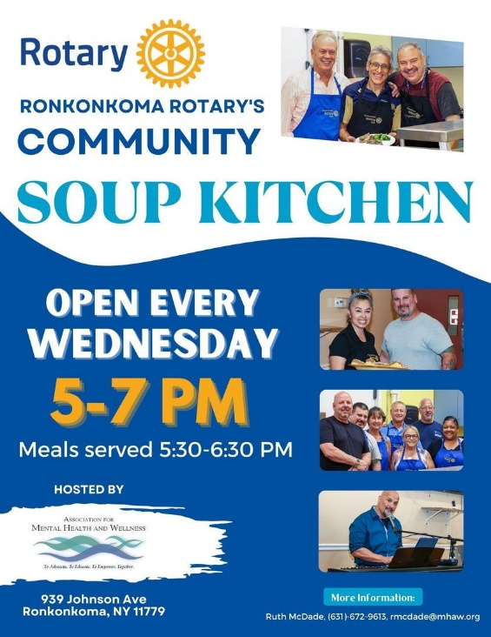

Attendees
Dianne Krasnoff, Bethany House
William Best, Bridges of Greater NY
Lindsay Caldiero, Brighter Tomorrows
Chris Ferraiolo, Catholic Charities
Jennifer DeGrijze, Community Housing Innovations
Molly England, ECLI-VIBES
Shirley Lara, EOC of Suffolk
Tara Corn, Friedberg JCC
Catherine Albanese, FSL
Danielle Devine, HELP USA
Stephen Brazeau, Hope House Ministries
Cara Cantor, Hope for Youth
MaryEllen Adams, Hope for Youth
Leticia Jones, Hope for Youth
Wayne Scallon, LICH
Yolanda Smith, LICH
Stephanie Reed, LICH
Petal Bowen-Walcott, LICH
Jonelle Redmond, LICH
Judy Batista Reyes, LICH
Alexis Goglas, LICH
Greta Guarton, LICH
Terri Tupper, LICH, LI Connections
Stephanie Warnken, Mercy Haven
Kathy Henry, MHANC
Ruth McDade, MHAW
Deirdre Trumpy, MOMMAS House
Angel Macchia, NC OCD
Salina Barnao, New Ground
Melissa Amodeo, Options
Romarie McCue, Retreat
Mayra Chacha, SEPA Mujer
Drena Collins, SAIL
Vicki McGinn, Suburban Housing
Gabrielle Fasano, SUS
Elizabeth Bazini, TSCLI
Colleen Juran, TSLI/HBB

